**INTRODUCTION TO MACHINE LEARNING**

**LAB ASSIGNMENT - 1**

**BASIC ML EXERCISES**

**NAME : PRATHAPANI SATWIKA**

**REG.NO. : 20BCD7160**

**Write down the descriptions for the commands used in each questions**

1. Write a Python program to load the wheat seeds data from a given csv file into a dataframe and print the shape of the data, type of the data and first 10 rows.

**CODE :**

import pandas as pd

data = pd.read_csv("seeds_dataset.csv")

print("Shape of the data:")

print(data.shape)

print("\nData Type:")

print(type(data))

print("\nFirst 10 rows:")

print(data.head(10))

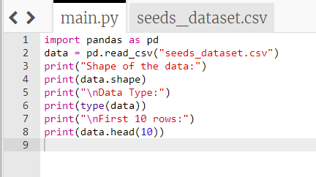

**OUTPUT :**

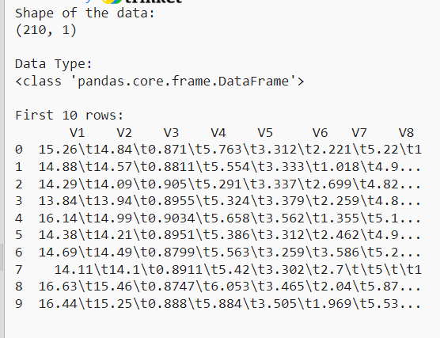

1. Write a Python program using Scikit-learn to print the keys, number of rows-columns, feature names and the description of the dataset

CODE :

import pandas as pd

seeds_dataset = pd.read_csv("seeds_dataset.csv")

print("\nKeys of seeds_dataset:")

print(seeds_dataset.keys())

print("\nNumber of rows and columns of seeds_dataset:")

print(seeds_dataset.shape)

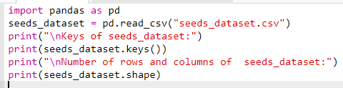

OUTPUT :

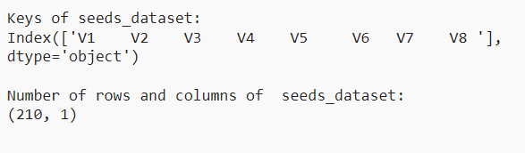

1. Write a Python program to get the number of observations, missing values and nan values.

CODE :

import pandas as pd

seeds_dataset = pd.read_csv("seeds_dataset.csv")

print(seeds_dataset.info())

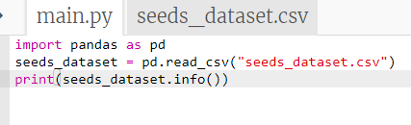

OUTPUT :

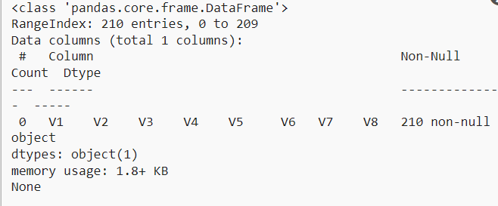

1. Write a Python program to create a 2-D array with ones on the diagonal and zeros elsewhere. Now convert the NumPy array to a SciPy sparse matrix in CSR format.

CODE :

1. Write a Python program to view basic statistical details like percentile, mean, std etc. of iris data.
2. Write a Python program to get observations of each class.
3. Write a Python program to drop Id column from a given Dataframe and print the modified part. Call the csv to create the Dataframe.
4. Write a Python program to access first four cells from a given Dataframe using the index and column labels. Call the csv to create the Dataframe.
5. Write a Python program to create a plot to get a general Statistics of dataset
6. Write a Python program to create a Bar plot to get the frequency of the three classes
7. Write a Python program to create a Pie plot to get the frequency of the three classes
8. Write a Python program to create a graph to find relationship between the length and width of the kernel.
9. Write a Python program to create a graph to find relationship between the perimeter and compactness.
10. Write a Python program to create a graph to see how the length and width of are distributed.
11. Write a Python program to create a joinplot to describe individual distributions on the same plot between length and width .Note: joinplot - Draw a plot of two variables with bivariate and univariate graphs.
12. Write a Python program to create a joinplot using "hexbin" to describe individual distributions on the same plot between length and width.
13. Write a Python program to create a joinplot using "kde" to describe individual distributions on the same plot between length and width.
14. Write a Python program to create a joinplot and add regression and kernel density fits using "reg" to describe individual distributions on the same plot between length and width.
15. Write a Python program to draw a scatterplot, then add a joint density estimate to describe individual distributions on the same plot between Length and width of the kernel
16. Write a Python program to create a joinplot using "kde" to describe individual distributions on the same plot between Length and width of the kernel  
     and use '+' sign as marker.
17. Write a Python program to create a pairplot of the data set and check which class seems to be the most separable.
18. Write a Python program to find the correlation between variables of wheat seeds data. Also create a heatmap using Seaborn to present their relations.
19. Write a Python program to create a box plot (or box-and-whisker plot) which shows the distribution of quantitative data in a way that facilitates comparisons between variables or across levels of a categorical variable of iris dataset. Use sEABORN